<https://www.youtube.com/watch?v=ks7xw5Fcxpw> . original video link

Theodore Postal, Professor of Science, Technology and National Security Policy in the Program in Science, Technology, and Society at MIT. [Bulletin of Atomic Scientists](https://www.google.com/url?sa=t&source=web&rct=j&opi=89978449&url=https://thebulletin.org/biography/theodore-a-postol/&ved=2ahUKEwi69pHN_vGJAxXbpokEHaTmCDwQFnoECDQQAQ&usg=AOvVaw3AU8RziJ9XgCCpsv6_9TKX) [University of Utah](https://www.google.com/url?sa=t&source=web&rct=j&opi=89978449&url=https://web.physics.utah.edu/~detar/phys4910/readings/ethics/Postol_TechRev_april2002.htm&ved=2ahUKEwi69pHN_vGJAxXbpokEHaTmCDwQFnoECDcQAQ&usg=AOvVaw3obnbsBRQ-rpdaYfJBNKoX) [Responsible Statecraft](https://www.google.com/url?sa=t&source=web&rct=j&opi=89978449&url=https://responsiblestatecraft.org/author/theodorepostol/&ved=2ahUKEwi69pHN_vGJAxXbpokEHaTmCDwQFnoECDYQAQ&usg=AOvVaw3zY4mbs7-doOakAkSFZ3em) [Declassify This](https://www.google.com/url?sa=t&source=web&rct=j&opi=89978449&url=https://responsiblestatecraft.org/author/theodorepostol/&ved=2ahUKEwi69pHN_vGJAxXbpokEHaTmCDwQFnoECDYQAQ&usg=AOvVaw3zY4mbs7-doOakAkSFZ3em) (MIT website) By the way, if you read the MIT web article go to the 5th paragraph and read this: In 1990 Dr. Postol received the American Physical Society's Leo Szilard Award. In my opinion, Leo Szilard Award is a greater honor for a physicist than a Nobel Prize. The Nobel Prize has become very political. I am waiting for them to give Joe Biden the Nobel Prize for Peace. Leo Szilard, a Hungarian, and Hungary overflows with genius people, John Von Newman for instance, is the physicist who woke up FDR to the great threat of Germany getting an atomic bomb first – they were working on it – and there is absolutely no uncertainty about it! Werner (pronounced Verner) Heisenberg was working on it for the NAZI (it was an do it or else thing). It was NOT Einstein! Leo Szilard was a friend of Einstein and persuaded Einstein to sign the letter Leo wrote to be delivered to FDR via a banking friend of Leo Szilard.

I consider that the warning that Dr. Postol is delivering to the U.S.A. and because of internet – the world – is even more urgent than what Leo Szilard did that day when he and fellow theoretical physicist Eugene Wigner (pronounced Vigner as the V in vinegar) By the way, Eugene Wigner was no scientific slough either. He was one of the founders in developing the Quantum Physics and receive the Nobel Prize in Physics. I take time to mention these details so that you will understand that Dr. Postol is one of these extraordinary people – and his warning – if you value the life of this country, your own and your children’s lives – you best to heed what he is saying to you.

Please note: This transcript is exactly as transcribed by <https://www.zamzar.com/manage/> ZAMZAR Online File Conversion. I have not edited it (for sure not the grammar as their computer will do a better job. And true also for the spelling. And too, as it is now 1:55 am 2024-NOV-23 South Chicago time, I will do it later. But if you are the particular type – and would like time stamps, etc., you can upload the audio, mp3 to <https://www.temi.com/> and you can option for pdf and also time stamps which is a nice feature. TEMI cost is 25 cents per minute. That for me is steep; also, you still have to or should proof read the transcript – it is research type material you are wanting to put to print. I plan to put segment the videos into two, possibly three sections so that those who are still working for a living and time is restricted – can listen to the shorter parts as time allows.

Rev 0, **Russia's New Missile: What it Means for Ukraine & the rest of the World w/Ted Postal, MIT**

Please note: (Unless otherwisse noted) Underlining and emphasis (making bold the print) is by nenadcuic.com

D Nuclear war. That's supposed to be the stuff of the past. Talking historically about the Second World War, and then Hiroshima, Nagasaki, etc., or even in the early part of the cold war, all those famous mushroom cloud videos we've seen for all the different nations that we're doing, nuclear testing above ground, etc., you know, all the people that were maybe the 1962 nuclear crosses with the Soviet Union when people were afraid that we were going to get into a nuclear war.

D People were diving under desk and having those drills and schools and all that, but that's in the past, or is it?

0:39

**D Part of the problem that we have right now, folks, is that we think that that stuff can't happen anymore**. That since it didn't happen in 1962, now everything's good to go, and our nuclear arsenal will prevent anyone to deter anyone else from using it, so we can rest easy.

D I've shown you many times on recent shows on some very imminent, highly qualified four-star, three-star generals, other people, former cabinet members, telling you not to worry about it. There's no way he's going to use, Putin is going to ever use nuclear weapons, so just rest easy.

D Well, listen, I'm telling you, things have been happening here of late that should wake people up and sober people up to realize that is not an unrealistic possibility. Now, whether it comes to many fruition or not, it depends on what we do next, and over the coming weeks, even before President Trump takes office on January 20th.

1:29

D Putinhas taken some action here in retaliation for American and Western and British action that has upped the ante a lot. Russia, first of all, talked about how they were going to lower the threshold for the use of nuclear weapons, and then that was almost immediately followed by Putin firing a new missile into Ukraine, which some people initially said was an intercontinental ballistic missile. Then later on, it was corrected to an intermediate range missile, but regardless, there was a new weapon used in war for the first time.

D And listen, we want to try to find out exactly what was deployed here and what the ramifications may mean, and there is nobody better to discuss this than **MIT professor Ted Postal**. We've had him on our show before about things in the Middle East, and he is on top of this one here.

2:16 D First of all, professor, welcome back to the show.

P Well, it's nice to be back. I don't think I'm quite on top of it, but I may have some things of interest to say.

D Well, you're certainly more on top of it than anybody in the mainstream media or anybody else that we've seen here who are really talking just in a little bullet points here and no analysis at all. So I know that you have some knowledge and

we're grateful to have it today. (i.e., Nov 22, 2024 )

P Unfortunately, all these so-called experts are fake to be blunt about it, and they don't know anything. In fact, I suspect that the people in positions of authority have not been told anything by the intelligence because the intelligence people are probably still trying to analyze what they now have, and they're probably not able to give the people in positions of authority much information. They probably can tell them about the launch of the missile. If it was a single missile, because we can see that from satellites, but other than that, I don't think they would have much analysis beyond what I'm able to show here today.

D Well, yeah, and that's still, we're very grateful to have that because while everybody else is trying to figure out,

it's not stopping politicians from making a lot of cocky comments without having to worry about what's coming out, which is one of the reasons I was so alarmed by it and wanted to have you on today to provide some actual sobering information out there that tells people to hang on a minute, don't get too cocky too quick until we know a little bit more.

3:49 D Now, this, I'm going to play a bit of a clipper from President Putin of Russia, who actually just, he made a lot of comments yesterday. We may show some of those in a bit, but he also said something just a couple of hours ago, so brand new, specifically talking about what kind of missile was fired.

4:06 President Putin address audience:

In this regard I would like to emphasis that ORESHNIK SYSTEM is not a modernization of the old Soviet (Union) systems although understandably, we all came out of various systems of The Soviet Union, we were all brought up on what was done by previous generations (pause and motion with r hand) ) to a certain extent. We used their (Soviet Union) results, but **THIS SYSTEM** is really, first of all, the result of work – because your work, the work that was done in Russian times (he is referring to the New Russsia, The Russian Federation, nc) in the conditions of The New Russia, was created by them (Russians belonging in the Russian Federation) on the basis of *modern state-of-the-art* developments. (ie., most recent and advanced technology, nc)

4:57 President Putin: And I must say that in today’s conditions, (ie., conditions of severe tensions between the affected nations) when we (Russian Federation, nc) are facing new and growing threats and challenges, the work on such weapons systems is . . .

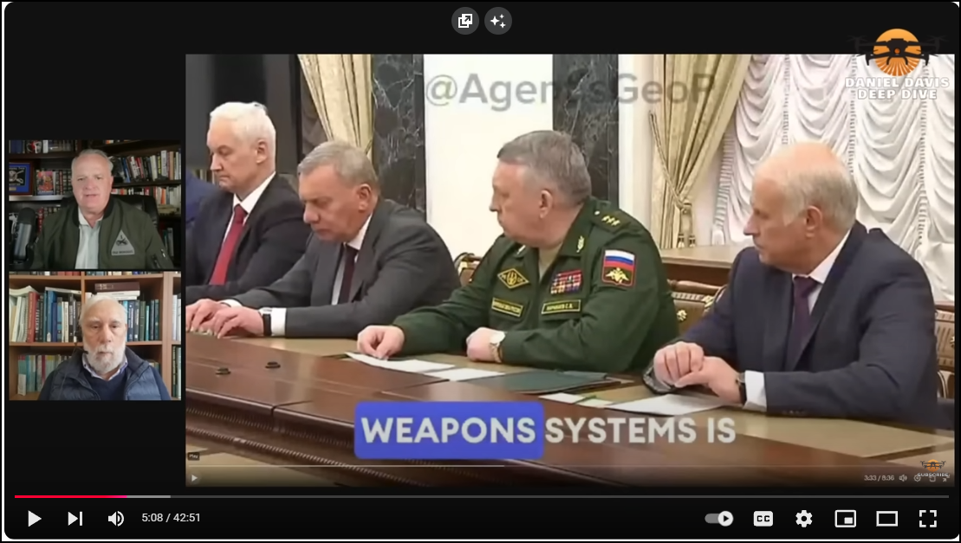

The President is still address his audience:

This is actually, before all, the results work, your work, the work that I had been doing in Russian, during the New Russia war, it was created on the basis of modern, new, developed, and it must be said that in today's conditions, when we are still growing up, we are growing up.

Daniel Davis (Deep Dive) breaks in:

5:03 D Okay, well, that's good enough for right now, Yuri, he's going on and talking about why he's developed this, but he makes an interesting claim there. In yesterday's speech that he made to the nation, he said it was an intermediate-range ballistic missile, as opposed to an ICBM that many in the Western initially said, which Zelensky himself actually claimed, but he said that it was an intermediate-range.

D Today, he said **it's a new missile, not just a refurbished old one**, but it's a new missile. What do you make of that?

5:32 P Well, I mean, a new missile can mean a lot of things. It wouldn't surprise me if it's a missile that uses pre-existing booster rockets, which doesn't mean it's an old missile because it's the front end of the missile, the payload section, that really requires all of the innovation. So it would seem to me that President Putin's statement **is almost certainly accurate**. In fact, it seems to me it's got to be accurate from what we see already, what we've already observed. But there may be pieces of the rocket that are from older times, because you have these big rocket stages. You can use them for all kinds of things. **I find his statements very plausible from what I've been looking at**.(6:35)

“ from google.com: Mach 10 is 10 times the speed of sound, or about 7,000 miles per hour. In 2004, NASA's X-43A became the first air-breathing hypersonic vehicle to reach Mach 10 speed. The X-43A was launched at roughly 110,000 feet and accelerated to Mach 10 using a supersonic-combustion ramjet engine. The X-43A's flight validated key technologies for air-breathing hypersonic aircraft. Flight speeds are classified by Mach regimes, as follows: Supersonic: 1.2–5.0 Mach Hypersonic: 5.0–10.0 Mach, High-hypersonic: 10.0–25.0 Mach See Top Gun Darkstar - This is what MACH 10 looks like. https://www.youtube.com/watch?v=5lCl-34v838&t=179s | https://www.youtube.com/@TheBuurPit . (WOW! I'm getting back under the covers. nc) from Google Science and TheBuurPit.

Note please. The Mach speed designation is in honor of the great Austrian (not German as is often alleged) great Austrian physicist. Einstein, though born in Germany through no fault of his, fled to Switzerland as soon as he could after finishing highschool (Gymnausium). It was in Switzerland that Einstein did his 2nd greatest work, Special Theory of Relativity. Albert credited the work of Ernst Mach with having much influence on him (See Einstein biographies, there are many). And it was in Switzerland that The General Theory of Relativity germinated and blossomed. His wife was Servian, by the way, and I am sure stimulated Albert to higher levels of achievements. Google search -->" Who was Ernst Mach; & https://www.google.com/url?sa=t&source=web&rct=j&opi=89978449&url=https://www.youtube.com/watch%3Fv%3DV_GYOdQfn44&ved=2ahUKEwiCgNGcnfOJAxVKvokEHePyAkkQ78AJegQIGxAB&usg=AOvVaw12G3JzxzKAS6EEAPH5olI8 et.al. nc

6:36 D Now, he (President Putin) said in his speeches yesterday (Nov 21, USA date) that this was because it was an intermediate-range and there used to be an intermediate-range treaty, which we broke, and then they eventually got out of as well. And so the claim is that's one of the reasons why they continued supporting on this, but one of the things he claimed was that, listen, this is a missile that flies it at Mach 10 [ , and it can't be intercepted. In fact, here's how he (President Putin) put it.

7:12 D Dandy, can you remind me when this starts at 250? (ps. Daniel Davis evidently talking with his camera man)

D (evidently) Yes, I believe it is. I'm sorry. I thought this was the one you already had queued up. Yeah, I think this starts at 250. 250, here we go. (Danny and Daniel would never make good Russian diplomats, in my opinion)

Audio translation is provided in the video therefore what follows is transcript of the President’s address to the Nation.

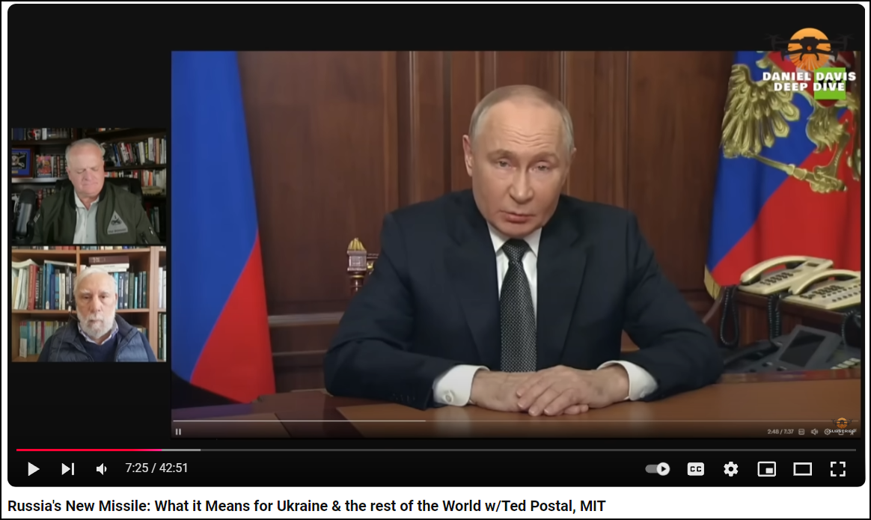

7:25 The President: Along the entire line of contact and all the objectives that we set before ourselves will be met. As a response to the use of US and UK manufactured weapons, the Russian forces have carried out a combined strike on one of the military industrial facilities in Ukraine. This included the test of a novel [ i.e., new ] intermediate-range a Russian missile system, a ballistic missile with a non-nuclear hypersonic payload was used.

8:08 The President: The test was carried out successfully. The objectives of the launch have been met. One of the largest and well-known industrial centers that is known.

Deep Dive interrupts …

Rev 1 segment concluded.

2024-NOV-2:45 pm Chicago time, USA At this point the above transcription will be posted. Then continue editing format at this point.

8:24 D That's good for their Gary. Harashaw. We'll cut that. We'll come back into the other part of a minute

ago. The one you already had queued up about talking about how they can't be knocked down.

He specified number one that this was a non-nuclear payload implying that there could be

a nuclear payload on the other. I want to talk about how those missiles work and how it exchanges

one more head for another. Well, I think that I made a guess about the missiles

or the missile, the single missile. I thought there were multiple missiles, but it looks like

it's a single missile with payloads that are dispersed. It's sort of funny because

I can show you a diagram that I produced 30 years ago for a fruitless talk to the

International Institute for Strategic Studies because nobody believed what I was talking about,

but it sounds to me like this is exactly what the Russians are displaying now.

If Gary, if you can show, here it is, this is the front slide, April 10, 1996.

But if you look at the next slide, I was showing a subunition deploying missile. In this case,

the subunitions could be packages which themselves contain subunitions. In other words,

there can be groups of subunitions in separate packages that then deploy smaller packages of

munitions. But the idea is that you disperse the different munitions along the direction,

which is shown at the apogee here, that's called the range insensitive axis. I'll explain what

that means. Basically, it's a direction in space where no matter what the speed you deploy the

object on, it will still land at the same location, but it will follow a different trajectory and it

will land at a different time. Let's look at the next slide. This is a very primitive drawing

because what I was trying to show is that a scud missile could be used to deploy missiles on short

range, subunitions on short range along in this case the range insensitive axis, which for the

scud missile is very close to perpendicular to its direction of motion. But in the next slide,

slide four, I show you, if you look at the leftmost brown arrow, the brown arrow shows you three

of the packages which are dispersed at the same time along the range insensitive axis,

which you see to the left. So you see on the bottom trajectory the object that was downward

with a downward velocity is moving ahead on a slightly different trajectory than the object above

it, which is moving basically on the trajectory that was originally, the missile was on, and then

you see further behind and yet a third trajectory on top, the object that's trailing further behind.

And if you look near the point of impact where there's a brown arrow, you can see all of these

things aligned up along the axis of arrival. So you would expect to see the munitions that are

dispersed spread out along the axis of arrival when they're arriving. So if we go to slide

six, we see here, bright areas in the sky, I have put in these ellipsoid areas, these are all,

these are probably clusters of munitions arriving roughly along the axis that's shown in this

particular diagram. And we have some video of that. Yeah, we can show the video. Let's look at

the video. This is real time, I guess, first. No, this is the slow video. One third, one third time.

That's okay. So you can see this coming in. There are six waves, or maybe really six deployments.

They're not very far apart in time. It all occurred over about a seven second arrival time,

which is perfectly reasonable, given the kinematics of the Kiplerian trajectory.

We're seeing our clouds of munitions coming in, and the camera can't discriminate between them

because the brightness of the objects are just washing out the camera's ability.

I was comparing this to the incoming Iranian missiles into Israel that we've talked about several

times before, and these at least to my eyes seem like you're traveling substantially faster.

They do appear to be traveling quite quite a lot faster, quite a lot faster because

probably they are designed to be aerodynamically to have what is called a large ballistic

coefficient. That basically means that the object is aerodynamically designed, so it will not

slow up very much in the atmosphere. In other words, it's trim, it's heavy, and it's aerodynamically

shaped. For example, if you have a ball going into the atmosphere, it's going to have a very low

ballistic coefficient because it's going to have a large aerodynamic area relative to a

rod-like object that weighs the same amount, which will have a much higher ballistic coefficient,

and will slow up much less. We'll also get much hotter, and in the case of these materials,

it may have stuff burning off, which would give it a bright hue around the object

that this video camera, which is a pretty primitive video camera, is unable to deal with. The

automatic brightness control for the video camera is just washed out, and the focal plane array,

where the images are being imaged onto, or have what's called bleeding, where the signal gets

bled into all the adjacent pixels, because it's too bright to be handled.

Jerry, could I get you to roll that other video we had of Putin talking about, whether or not these

missiles can be shot down? There is no way to counteract a missile that flies it at 10 Mac, which is

2.5 to 3, umptest per second, existing anti-missile systems, and the anti-missile systems deployed

by the United States and Europe cannot intercept such missiles. It is impossible.

Now, I've heard Ted that many in the West, some of these experts that you described a minute ago,

are saying, well, this is older technology. This is old RS-26, I think, which has been around since

I want to say 2011, something like that, but that this is just Putin blustering. He's just trying

to bluff you into thinking that these can't be shot down, because we have the Thad anti-aircraft

system, and we can do it. What do you say to that? I'm glad they know this, because I didn't know this.

I had to do some work on this, unlike what it sounds like they did.

This is a new system. There's no question it's a new system. Anybody who claims otherwise has

not looked at the data. There's no question this is a new system. It's a system that fragments the

warhead into many pieces, and those pieces would have to be intercepted independently by multiple

interceptors, so there were 23 separate clusters of objects that came in. I say 23 clusters of

objects, so there were 23 packages of some kind that deployed additional groups of munitions.

God knows how many of these targets they would have to be dealt with with interceptors, especially

hit the kill interceptors, which can do nothing, but destroy an object within fractions of a meter

of it. When you were talking about during the last Iranian attack into Israel, especially because

there were more missiles that were fired there, and you showed a lot of the video where they were

coming in, and they were fast, but not near as fast as this, and you pointed out that most of those

were not hit, even on the air bases here. Do you think that whether it's Patriot or

the dense David Slanger or the Thad system, can they knock these out?

No, there's no way they could knock these out. The Thad system in particular, well the Patriot as

well, that you shoot an interceptor, all the best you can do is if you happen to hit one of the

munitions. Now there are 23 packages of munitions, and we are not seeing the packages come in. We are

seeing a cloud of munitions deployed by each independent package, each of the 23 packages.

So those 23 packages are made up of, I don't know how many munitions, I just don't know,

but if they engaged one of the packages, which would already have deployed its subunitions,

they would only be able to hit one munition at best if they even can hit that, and all the rest

would come through, so effectively they could destroy nothing. You would take the whole, the whole

Thad battery only has 48 interceptors in it. You could expend the whole Thad battery on this

system and only destroy if everything hit something, which is very doubtful, you could have only

destroyed a small fraction of the payload on this mission, on this missile. So I don't know what

these people are talking about. Now those videos you've shown there that have been making their rounds

on social media and on mainstream media a lot, but one that hasn't is something that I saw on

military summary this morning out of Kazakhstan, which has a very very interesting signature,

I'd like your view on here, if you can roll that tape. We have very interesting videos that were

published from the border with Kazakhstan, let's take a look at them, and according to the author

of this video, here we can see the flight pass of the Ariechnik missile. I can't tell you for sure

what the Israel are not, maybe this is something else, but the sources are saying that this is exactly

the Ariechnik missile that was heading towards Nipropetrovs, Nipro on the territory of Ukraine,

and we have this Ariechnik missile from another angle, and this is the same missile, but from another

angle also, somewhere from the part of Russia between Kazakhstan and Ukraine. And of course,

people are asking questions why the Russians decided to call the missile of Ariechnik by the name

of Ariechnik, and today we got very interesting analysis and very interesting photo, for example,

right in the left picture we can see Ariechnik, and in English it sounds like Hazel, Hazel, Hazel,

and to the right we can see the Russians, the Ariechnik warheads, so as you can see there are

lots of similar things, and this is the reason why the Russians decided to call the missile

of Ariechnik by the name of Ariechnik, in English it sounds Hazel.

Now the closest I have ever seen that signature of anything in the air is like,

I mean we're back in the days when I was a kid in the Saturn V rocket, when it was going up

into the space in some of the lunar modules, whatever, and you had that big plume off of it,

but I've never seen anything else like that, certainly in missiles, have you seen anything like

this, and what do you make of it? Yeah, I hope you guys will send me these videos so I can do

further work on them, take a look at them more carefully, I appreciate them because I haven't

had a chance to look at them, but what I think may be happening, this is again a guess,

is what we were seeing was the plume from a rocket vehicle that had multiple rocket motors on it,

and each of those rocket motors was propelling a package of subunitions that would then be deployed

into a target area, I'm just guessing, this is just a guess, but that's certainly a different

rocket system if that guess is correct, and no unitary rocket established from the border,

with Kazakhstan let's take a unitary rocket stage does not look like this,

because it has a single exhaust plume, now the plume is spread out because it's at high altitude,

and the different rocket motors are clustered together, and it's a very low pressure

in the atmosphere at this high altitude, so the plumes are spreading out, but I think this is a

multiple, this is a rocket that is a cluster, separate rocket motors, and that probably that cluster

is deploying separate vehicles that are themselves deploying clusters of munitions,

and anybody who thinks that they can intercept that, who knows what they're talking,

I mean they can't know what they're talking about if they think they can intercept that,

and I know you've had some b-roll that we've shown before, that one image we've shown there,

both at full time and one third time, is one, but there's another one where the impacts are

coming through clouds or something, if you could pull one of those up, because I wonder if you could,

if you still have those Gary, okay he's going to be able to pull them up, what he's going to show

here, I wonder if you can talk, is they seem to have a different signature as they're coming in,

and again, this is very different than anything we've seen in the Iranian missile attacks or so,

I don't know if you could talk a little bit about when these come up. Well we'll see if I can

understand what I'm looking at, but I guess there's a new weapon, anyone who says otherwise

doesn't know what they're talking about and hasn't looked at the data. And actually before we

bring it up here, I wonder if you can talk about the difference, what is the difference in

performance of the missile and of the impacts between a conventional warhead and a nuclear warhead?

Yeah, that's the one I was talking about there. But yeah, before you talk about that video though,

if you could, because that seems to be, that's something that Putin has commented on several times

here, that this could be, those were conventional warheads, but it could be a nuclear warhead.

Would that, what impact would that have on the performance of the missile?

Well, it could be a cluster of munitions, but if it were a nuclear warhead, it would be accompanied

by numerous decoys. So in other words, instead of having many, many sub munitions, you would

you do is you have a much larger warhead, and you have much smaller decoys, and those decoys

replicate a radar and infrared signal that makes them look like the big warhead, the nuclear warhead,

so that you can't tell the difference between the nuclear warhead and the decoy.

And we've already seen decoys flown by the Russians. We saw decoys early in the war,

when if we get on again somewhat later, I can pull up some of the photographs I have of decoys

that were on the ISC on their missiles. So there were definitely decoys, and those decoys were

designed to confuse radars and infrared homing systems. No question about it. The Russian's

deployed decoys. I have other images of decoys, the Russians build, and certainly when they're

traveling that fast, you almost don't even need them anyway. So having that as a nuclear payload

is no problem, and would certainly be extremely difficult to intercept, and at very best,

I mean the most careful technical statement you could make is against the perfect missile

defense system, it would have a much less than perfect intercept rate, because the number of

interceptors you would need would be enormous because of all the decoys, and you just don't have

that. It's just not practical. These interceptors are so expensive, and so limited in numbers.

Right. This system could readily be defeated. For example, you could send, let's say two or three

of these systems in, only one of which had a nuclear warhead and decoys on it, and the other two

could have befilled with decoys. So you'd have, you know, God knows how dozens and dozens and maybe

hundreds of decoys. How are you going to deal with that? So, Putin is absolutely correct.

So since they want to say this guy's bluffing, they ought to know what they're talking about before

they say the guy's bluffing. It's incredible to me. It's really incredible to me the reckless

behavior of these people. Well believe me, I'm right with you on that one. If you can bring that

video up in here, I wonder if you can talk just a little bit about what we're seeing in this video

right here. I'm actually not sure what we're seeing. I'll have to look at this. First of all,

it's coming through the clouds. It's a cluster of things. It's got a very big plume or more likely

it's got a group of, it's a cloud of materials that looks to me because it's not falling.

It's not aligned with this direction of motion. So it could be a cluster of munitions,

which are all creating their own luminous region. I'd have to look at it, but it's not necessarily

different in terms of the physical behavior, you know, the physical images of what we're seeing.

But it's different from, you know, it's a different set of images than I've tried to analyze.

But I think it might be a cluster of munitions coming through, all of which are on, in this case,

a near vertical trajectory, but spread out over the width of the incoming trajectory. That's what

I'm guessing. I haven't studied it yet. From looking at this one, the one that's shown right now,

because I mean, they, when you see these are coming in, they're more spread out. Right, right.

That was what I was going to ask. When you're targeting something, I mean, this seems that

it would be an area weapon. And you, you talked a lot about CEP and everything else.

You can, based on what you've seen here or didn't know, can you talk about how accurate the

aim point may be from whatever they're trying to hit? Well, that's, I would say it would take

quite a bit of analysis. I don't see, you know, I just don't know. I mean, I think that without

knowing what the target set is and what they hit, and where the damage was, it would be very

hard to make any reach any conclusions about the accuracy of this system. It's just if we can

get some data on what was hit and what the levels of damage were, we could tell if these systems had

a higher precision of accuracy. But, but I guess in any case, if it has a nuclear payload,

it's not going to make any difference. It's not good. Close is good enough with a nuclear weapon,

as we often say. So, what, what is your bottom line about how concerned you are about the capacity

of Russia to make good on some of these threats that they would attack Western targets outside

of Ukraine, if our, if we continue firing long-range missiles into Russia? Well, I think they've

demonstrated that they have quite a substantial capability. I think it's not an accident

that this missile had a three-kilometer speed, because that means that the ammunition,

the payload, traveled at a minimum from a thousand-kilometer range, at a minimum, I say, because I

don't know if this payload was gliding during part of its trajectory. If it just followed a ballistic

trajectory, then with reentry and, of course, slowing up and luminous heating, then it was,

it came from about a one thousand-kilometer range. That's a ballistic trajectory. But, of course,

if it hit the top of the atmosphere, the top of the atmosphere may be being 50 or 60 or 70 kilometers

altitude. At three kilometers per second speed, you could, you could skip off the atmosphere and glide

a bit. And so it could have come from a couple of thousand kilometers. My guess, but I haven't

done the work. I want to be very careful here. I'll have more to say if we talk again. My guess is

it came from Chirotam, if it came from in Kazakhstan, because that's a big launch site. And Chirotam

would be, I don't know what the range to Chirotam is, but that would give us some guess.

So the people in the intelligence, American intelligence community, if they, they would know,

at this, they would already know that there was a launch from some place in Russia.

And probably, if I guess it's Chirotam, they would know that this missile was, if Chirotam is

more than a thousand kilometers away, which I think may well be the case, they would know

that the incoming system was some kind of boost glide system. In other words, it boosted to a high

speed, three kilometers per second. And then it was skipping off the atmosphere, gliding

above the atmosphere, and then turned down. Is there any way to tell from radar or anything else

whether it's got a nuclear or conventional payload? No, you don't know. You cannot tell by radar

or infrared, no. But you can see the trail, the American satellites, I'll have data on that for

another discussion, have very, very high sensitivity. So I have a little doubt that the Americans were

able to see the luminous objects, the most luminous objects while they were skipping off the atmosphere.

This is not a normal thing they would be able to see. If they were just warheads, they wouldn't see

them. But these are bright objects. And so they would have seen a bright contrail from these objects.

So they would have known that this is a boost, this is a boost glide kind of system.

And if they think that this is not a new system, I don't know what they're going.

It's absolutely a new system. And it's going to be a very capable system.

So now, I don't think it's an accident that it was done from long range because the Russians

have been following the intermediate nuclear force agreement even though the United States backed

out of the agreement because they have very wisely understood that if we have an arms race

in northern Europe with shorter range missiles, it's going to escalate into something that's

going to turn northern Europe into a tender box that could go up into a third world nuclear war

instantaneously. I'm very short notice. So this event is also tied in my judgment

to the discussion of deployments of specialized boost glide missiles by the United States in

2026 in Germany. So basically, what Putin is showing is that he has a system right now,

not in 2026 that is comparable to the boost glide systems that the United States is still trying

to develop. And those systems are not going to be good to be introduced in Europe by either Russia

or the United States because it's going to drive the timelines down to a few minutes at most.

You know, for nuclear attack warning. And that's going to put everybody on the most short

early warning attack posture you can imagine. So this is a warning for those people who don't

have enough neurons to rub together to understand what Putin is saying here because he's really saying

guys, this is serious. We have the ability to deploy the kinds of weapons you guys are talking

in 2026 in Germany. And you Germans better figure out that you're a target. I've already given

some talks to audiences in Germany about this problem of these missiles that the United States

wants to deploy with Germany in 2026. This is going to drive the warning times down to minutes

or shorter. And this is going to create a nuclear warning situation that will drive the risks

of an accidental nuclear warning and a false alert or an accidental mess of launch through the

roof. This is really going to increase the danger of an accidental nuclear war. I cannot emphasize

this enough. We have people in positions of decision-making positions who have no idea what

they're doing. If they are engaging in this kind of behavior and they have no idea what they're

actually doing and it's becoming clearer and clearer, they do not know what they're doing.

Mr. Putin just sent them a message. Yeah, and send me a message because I knew this is a problem

earlier. And unfortunately, Professor, it doesn't look like that message is being received. We

on a show earlier this afternoon showed comments by a British Prime Minister, Kier Starmer and

the new NATO Secretary General, Mark Ruta, that they're still talking about winning for Ukraine.

Still, to this day, after these missile launches in the case of Starmer, although they didn't need

it because as you said, the knowledge has been out there. But I think we're getting into a really

really dangerous period. More dangerous than a lot of people recognize. We need to send shows like

this and your comments out here, which is why we're so grateful to have you on today. So people

are aware that this is no game. This is no joke. This is no movie. We're talking about existential

issues here. And we need to we need to cool things down right now and not wait a couple of

months before Trump gets it because God only knows what may happen in between now and then.

This is the joint U.S. NATO escalation of attacks with Ukraine against Russia and with China

and North Korea joining Russia to form an alliance against the West. Would not you say that

World War Three has begun? I would not say that. That is not the characterization,

characterization that this building assesses. And you've seen us take measures to deescalate tensions

and to and I'm sorry, I'm just speaking like broadly around the world. But when it comes to Ukraine,

the commitment of this administration from the very beginning of this war was to help Ukraine take

back its sovereign territory. A decision by another country to invade its sovereign neighbor cannot

go unchecked. And that's why you've seen not just the United States, but 50 or so countries

all around the world come together and support Ukraine through the Ukraine Defense contact group.

That was just two days ago. This is a joke. I mean, she does. I hate to, you know, I really,

I mean, the incompetence of that, well, dishonest state, maybe it's a better way of that statement is

just mind blowing. I mean, the United States attacked a sovereign country that has thousands

of nuclear weapons. What is she talking about? That we're trying to not have an escalation?

Yeah, we're trying. We're taking three measures. Explain that.

Yeah. I mean, what is she living a different world? Well, see, that's the problem. I mean,

you see, that's the Department of Defense official spokesman or deputy spokesman. You

secure Starmer. And you, you see, you know, obviously, Zelensky, they're just making all these

claims. And Mark Ruta, the national NATO, hit his head. It's a lot of people. That's why I say,

this is a really dangerous people and the truth needs to get out there. So listen, it's not, you

know, great news, not great information, but it's stuff that regular people need to know. And so

I'm asking folks to, you know, man, share this with people. Make sure that people know that this

is a real issue because we need to get to our leaders and make sure that they're aware of what

the stakes really are. This is a warning from Putin that if you, if the West tries to escalate

the confrontation with nuclear weapons by driving the warning times even shorter

than they already are, which is what the West will be doing if it deploys hypersonic missiles

in Germany. This is his message saying to can play this game. And it's not a game that's a good

game for any of us to play. He's showing restraint here. He's demonstrating something, but you

have to be smart enough and well informed. And I mean, frankly, I'm glad that Tulsi Gabbard

is likely to be the next director of national intelligence because she understands this. I've

talked to her about this kind of thing. She knows what she's doing. This this drive by shooting

that's been going on against Tulsi Gabbard is outrageous. And, you know, I can't begin to say

how furious I am that an individual who's done so much in service of her country. And when I

tried to do the right thing, in spite of being criticized, has been attacked by the so-called

liberal West Westerners who claim to be interested in freedom. So what you do is you go on and

you try a McCarthyist attack on a person who served the country who has served the country well.

If you don't agree with her, okay, I don't agree with her on everything. That's what the democracy

is about. This is ridiculous. And I'm sorry to be so angry, but I just had it with these people.

Yeah. Well, we've had a couple of shows on that very topic. So I'm right with you on that as well.

And I'm grateful for for picks of that caliber and quality in our governor government.

Because so if we can get to February or January 20th, and then we've got a better shot

than we do now, we just have to hope that the current administration doesn't do anything rash.

Well, listen, Professor, I really appreciate you coming on today. This is one of the more sobering

shows we have because at least when we're talking about the Iran and Israel issue, that was kind

of in the Middle East, but this is directly related to our national security. So it's a little bit

more important. Thank you for coming. Absolutely. And please, Gary, send me those videos.

I'll take a look at them and you've already ruined my day yesterday. So you're there. It's all

ruined another day. Yeah, well, all right. Well, thanks a lot, Professor. We appreciate it.

Appreciate you guys watching us today too. Be sure to like and subscribe. Be sure to pass this one

out to other people who believe me. People need to know the truth about this deal, especially.

And lastly, also we're we have our unpodcast now. And I know a lot of you can't watch every video.

So please do go to Apple podcast, Spotify podcast addict anywhere you get your podcasts to

top in Daniel Davis deep dive. Make sure you top all those words in there and you'll be brought

right to our our offerings there. So thank you very much. And we will see you tomorrow on Daniel

Davis deep dive.